IGP Project Report – Sameer Sabale

Project Overview:
In this project, I have set up a DevOps pipeline using multiple tools and technologies to automate the deployment and monitoring of applications. The infrastructure involves 4 servers:
- It is a using for Jump server For Docker, Jenkins, Git, and Maven.
- Master and Worker Servers (3 servers): For setting up a Kubernetes cluster.
The goal was to integrate version control, continuous integration, continuous deployment, and monitoring tools to provide a complete DevOps pipeline.

Task 1: Git Setup and Code Version Control
- Install Git:
  - Installed Git on the jump server to manage version control for the source code of ABC Technologies.
- Download the Source Code:
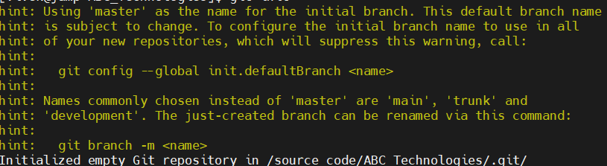
  - The project source code was downloaded from the relevant repository to initialize the Git environment.

- Initialize Git:
  - Initialized Git in the project directory using the git init command.
- Move Code to Staging Area:
  - The necessary changes were staged using git add . to move the code into the staging area.
- Check Git Status:
  - To verify the changes, ran the git status command to check for any uncommitted changes.

- Commit and Push Code:
  - After committing the changes using git commit -m "Initial commit", pushed the code to the master branch on GitHub.
  - The repository URL is: [GitHub Repo Link]

Task 2: Jenkins Pipeline Setup
- Install Jenkins:
  - Installed Jenkins on the jump server to manage continuous integration.

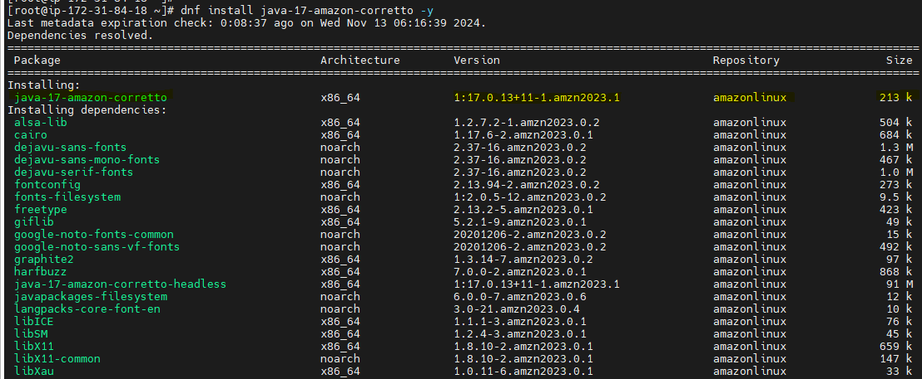
- Install Maven:
  - Maven was installed to manage dependencies and build the application.
- Configure Jenkins:
  - After logging into Jenkins, created a pipeline folder to organize the project.
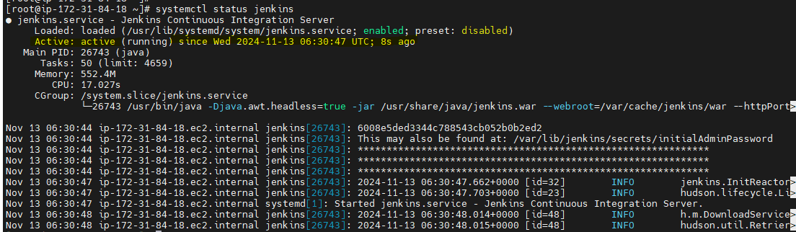

- Pipeline Script:
  - The pipeline script, which automates the build and deployment process, is available in the GitHub repository.
  - This script runs the pipeline and deploys the application on a Tomcat Web Server.

- Pipeline Execution:
  - Ran the pipeline to test its functionality. The pipeline worked successfully, and the output was verified through Jenkins logs.

Task 3: Docker Image Build and Deployment
- Install Docker:
  - Installed Docker on the jump server for containerizing the application.

- Login to Docker:
  - Logged into Docker with the necessary credentials using the docker login command.
- Build Docker Image:
  - Created a Docker image from the application’s source code using docker build -t <image_name> ..

- Deploy to Docker Container:
  - Deployed the Docker image to a container for testing, and the application was accessed via the container’s IP address with the bound port using the docker run -d -p <port>:<container_port> <image_name> command.
- Push Docker Image to Docker Hub:
  - After confirming the container was working correctly, I pushed the Docker image to Docker Hub using docker push <dockerhub_username>/<image_name>.

Task 4: Kubernetes Cluster Deployment
- Set Up Kubernetes Cluster:

  - Set up a Kubernetes cluster using 1 master and 2 worker nodes for the deployment of ABC Technologies' application.

- Deployment and Service Files:
  - Wrote the necessary deployment and service files for Kubernetes, creating the pods using the kubectl apply -f <file_name> command.

- Create Docker Secret for Authentication:
  - Created a secret file to securely pull Docker images from Docker Hub into the Kubernetes cluster using the kubectl create secret docker-registry <secret_name> --docker-server=<dockerhub_url> --docker-username=<username> --docker-password=<password> --docker-email=<email> command.
- Pod Verification:
  - The pods were successfully created, and I verified the deployment using Kubernetes CLI commands like kubectl get pods.
- NodePort for Access:
  - The application was made accessible through a NodePort, providing external access to the services running inside the Kubernetes pods using kubectl expose pod <pod_name> --type=NodePort --name=<service_name>.

Task 5: Kubernetes Monitoring Setup
- Install Monitoring Tools:
  - For monitoring the cluster, I installed the following Helm charts:
    - helm repo add stable https://charts.helm.sh/stable
    - helm repo add prometheus-community https://prometheus-community.github.io/helm-charts
    - helm search repo prometheus-community
- Create Prometheus Namespace:
  - Created a Prometheus namespace for the monitoring tools to be deployed using the kubectl create namespace prometheus command.

- Verify Monitoring Pods:
  - Confirmed the Prometheus and monitoring pods were running properly using kubectl get pods -n prometheus.
- Grafana Dashboard Setup:
  - Logged into Grafana using NodePort and set up dashboards to monitor the application performance.

- Monitoring Data:
  - Monitored various metrics, including:
    - Network input/output data.
    - CPU utilization of containers.
    - Memory utilization of containers.
- Prometheus Queries:
  - Configured Prometheus queries for detailed insights and performance data of the Kubernetes cluster and containers.

Conclusion:
This project demonstrates the full cycle of DevOps automation for ABC Technologies, from source code management to continuous integration and deployment with Docker and Kubernetes. The integration of monitoring tools like Prometheus and Grafana further enhances the observability of the system, allowing for better management and troubleshooting.
By completing this project, I have gained hands-on experience with key DevOps tools, which will help in automating deployments, scaling applications, and ensuring their stability in production environments for ABC Technologies.

